Lesson 3 : inequality

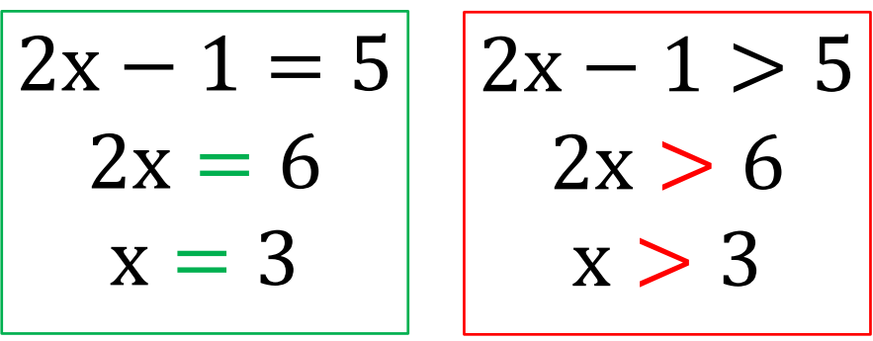
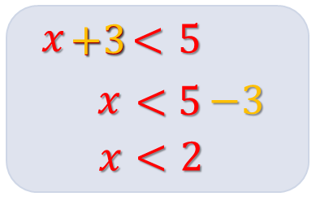
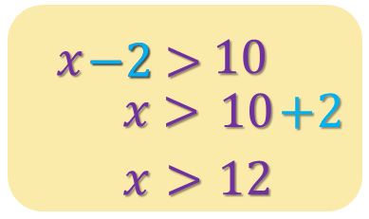
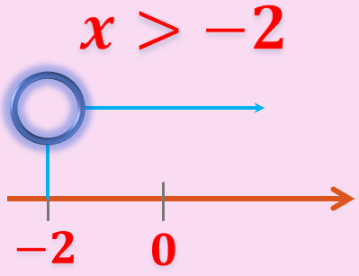
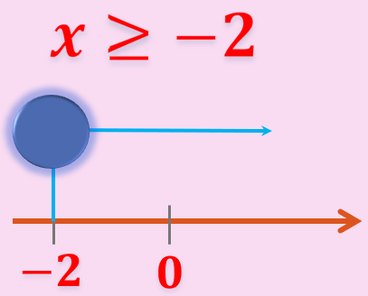
Checkpoint 1
Checkpoint 2

$$5<2x-1$$
$$6<2x$$
$$3<x$$
$$x>3$$
Make subject
主角放左邊
唔好冇大冇細

Let’s get started!

Solve the following inequalities graphically.

1. $x+3<7$

3. $x+6≤10$

5. $11≥3+x$

7. $10<15-x$

9. $287≥106+x$

2. $x-3>7$

4. $7<x-15$

6. $10+x<27$

8. $209≤300-x$

10. $256-x<96$

Checkpoint 3

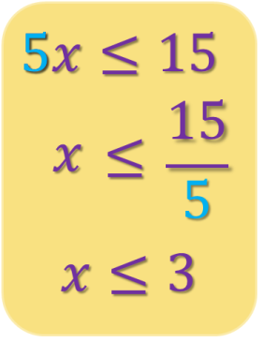
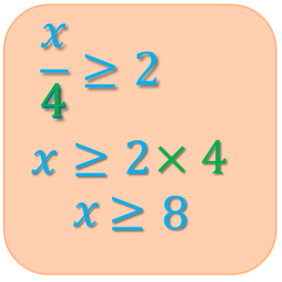

You have learnt more! Go on!

Solve the following inequalities graphically.
11. $3x<15$

13. $\frac{x}{8}<9$

15. $15<\frac{x}{6}$

17. $\frac{24x}{5}≥48$

19. $9<\frac{3x}{35}$

21. $\frac{5x}{18}<10$

12. $2x<86$

14. $\frac{x}{7}≤13$

16. $32≥\frac{x}{3}$

18. $258<\frac{3x}{2}$

20. $\frac{3x}{7}<8$

22. $\frac{216x}{9}≤24$

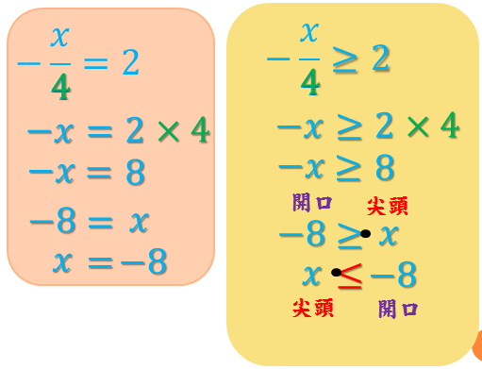
Checkpoint 4

$$-x<4$$
$$x>-4$$
乘除負數
大細調轉

Keep Fighting!

23. $-x+3>7$

25. $x+2≥4+3x$

27. $-4x+7>5$

29. $10-2x≥x+1$

31. $x+4>4x-8$

33. $4\left(x-1\right)≥7x-10$

24. $-2x+5<17$

26. $13≤9x-5$

28. $2x+3<10x-5$

30. $5-3x≤-1+3x$

32. $-30+12x<42$

34. $6(3-x)≤4(-2x+3)$

35. $2x+3>5(2x-1)$

37. $12-2x≥x+3$

39. $x+4>4x-8$

41. $4x-12≥10-7x$

43. $-6(5-2x)>42$

45. $\frac{1}{5}\left(-4-x\right)≥8$

36. $6(3-x)<4(-2x+3)$

38. $4-2x≤-1+2x$

40. $5x-1<3x-7$

42. $13-5x≤23-7x$

44. $5(x-8)<10$

46. $\frac{1}{3}(4x-1)≤1$

Give it a try

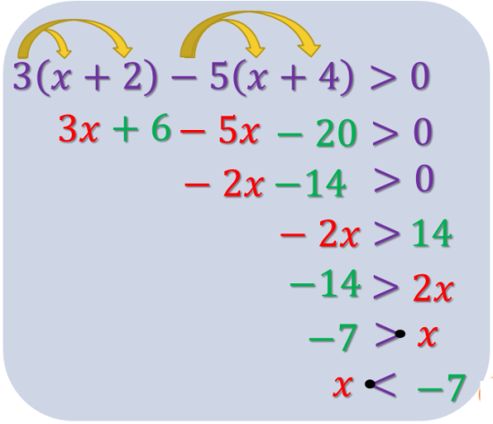
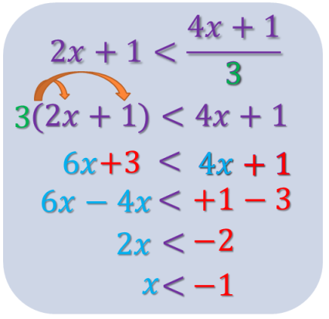
一邊有分母 $n$,
其他terms全部 × $\frac{n}{n}$
Challenging!!

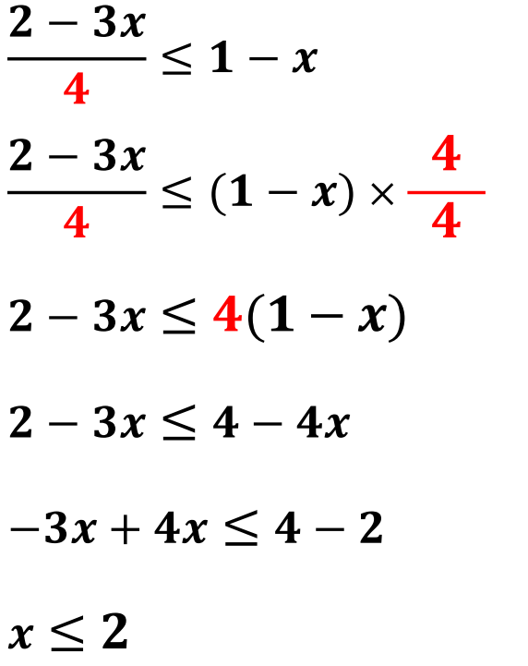
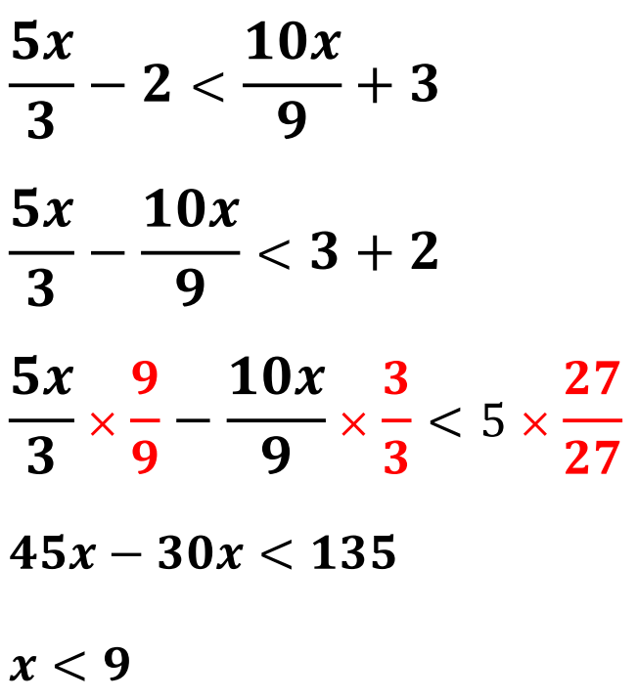
Case 1
Case 2
$\frac{9}{9}$ × $\frac{3}{3}$

Final Boss!

1. $\frac{x+1}{2}≥\frac{9x+5}{19}$

3. $\frac{6-x}{11}-\frac{1-x}{4}<0$

5. $x+16>\frac{2x}{13}+5$

7. $4x+16+\frac{x}{2}<13$

2. $\frac{3x+8}{2}≥\frac{3-x}{5}$

4. $\frac{5x-3}{4}-\frac{7x-25}{3}≤0$

6. $\frac{5x}{3}-2<\frac{10x}{9}+3$

8. $7-4x>\frac{x+1}{3}$

9. $1+\frac{x}{7}+\frac{x-3}{2}≥3(x+1)$

11. $3-\frac{x+1}{2}≥5-\frac{x+2}{3}$

13. $\frac{-3x+5}{2}≥\frac{11-x}{3}$

10. $5x-\frac{2x-9}{5}≤x-3$

12. $\frac{1-2x}{3}-\frac{3-4x}{5}>-2$

14. $\frac{x}{6}+1≤\frac{5}{6}-x$

